SOP for YeLink
Application: An interface that turns software commands into hardware actions, connecting EthoVision and other experiment software to external devices.

One-Time Setup
- Flash the Arduino firmware
  - Open YeLink.ino in Arduino IDE and flash it to Arduino Uno R3.
- Optional: Test the Arduino
  - Open the Arduino IDE Serial Monitor
  - Test the connection by manually sending: p=13,v=1,d=5
  - Confirm that the command works correctly with pin13-LED on Arduino Uno R3
  - Close the Serial Monitor after testing.
- Optional: Rebuild the exe files (only needed if you want to modify the .cs source code)
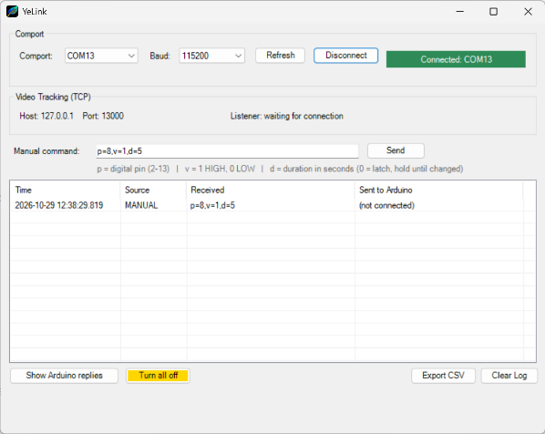
  - Run YeLink_build_ui.bat to recompile files.
Experimental Procedure
- Connect the Arduino
  - Connect Arduino to the PC and identify its COM port in Device Manager.
- Start YeLink_AdapterUI
  - Launch YeLink_AdapterUI.exe.
  - Select the correct COM port and connect: it should shows “Connected”.
  - Leave YeLink_AdapterUI running.
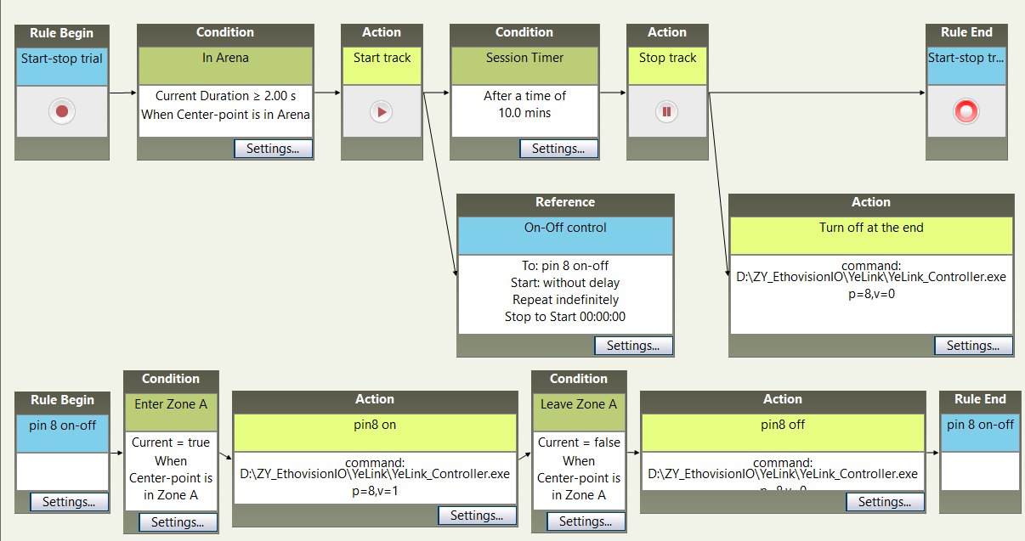
- Configure EthoVision
  - In EthoVision, create an External Command Action.
  - Set Select program to run to: YeLink_Controller.exe
  - Enter the desired command under Command line options (accepted pins 2-13).
Examples:
    - p=8,v=1 → turn Pin 8 ON
    - p=8,v=1,d=30 → turn Pin 8 ON for 30 seconds
    - p=8,v=0 → turn Pin 8 OFF
- Run the Experiment
  - Start the experiment in EthoVision.
  - Keep YeLink_AdapterUI running throughout the session.
  - Monitor the Adapter log to confirm that commands are being received and executed correctly.

